**Initial setup**

* Create the DataBase
* Create the database named “DemoApiDb”

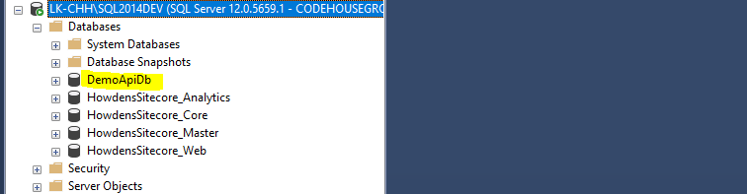

* Clone the solution and run the script (create table) to setup the tables (<https://github.com/Chamodh9311/DemoApi/tree/master/DbScripts>)

<https://github.com/Chamodh9311/DemoApi>

* Open the web.config file in root folder and change the sql connection instance to reflect with your local connection instance.
* Add bearer token for the request

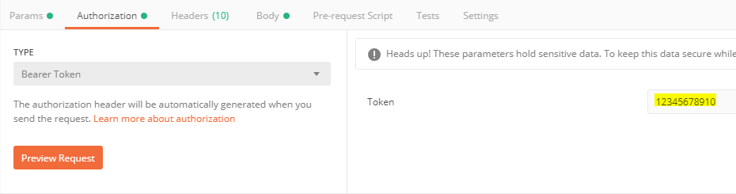

* Host URL – highlighted text needs to be replaced from your site URL (visual studio localhost or IIS hosted)

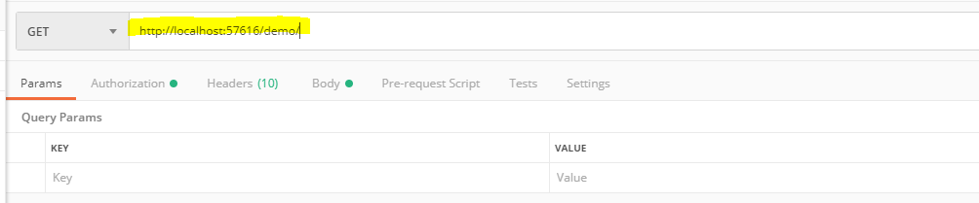

**Sample requests**

1. **Create customer (*demo/CreateCustomer)**

Note - please provide email and name in the request.

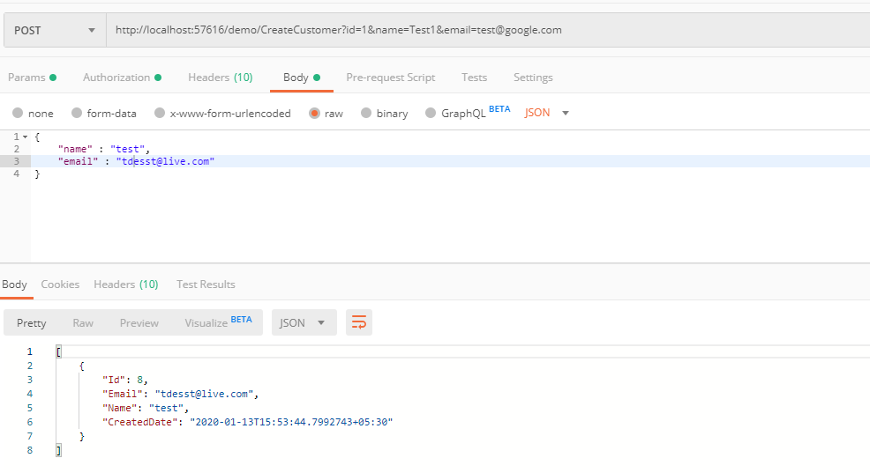

1. **Update Customer- (*demo/UpdateCustomer/)**

Note – please provide an existing user Id, email and name in the request.

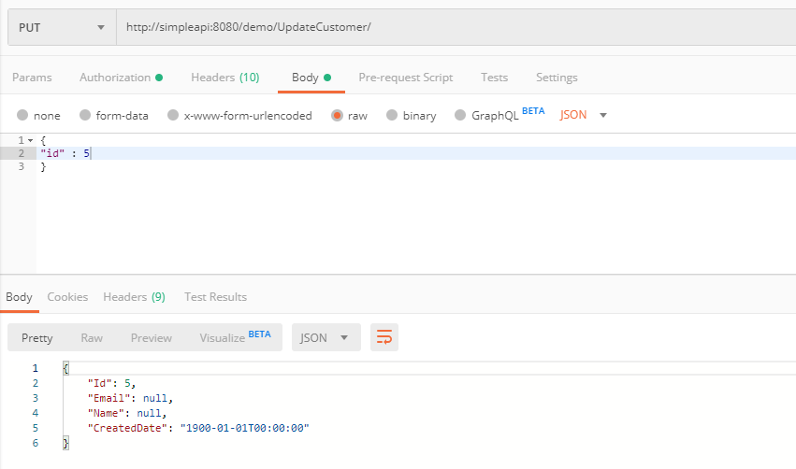

1. **Delete Customer – (*demo/DeleteCustomer/)**

Note – deleted customer details will be returned.

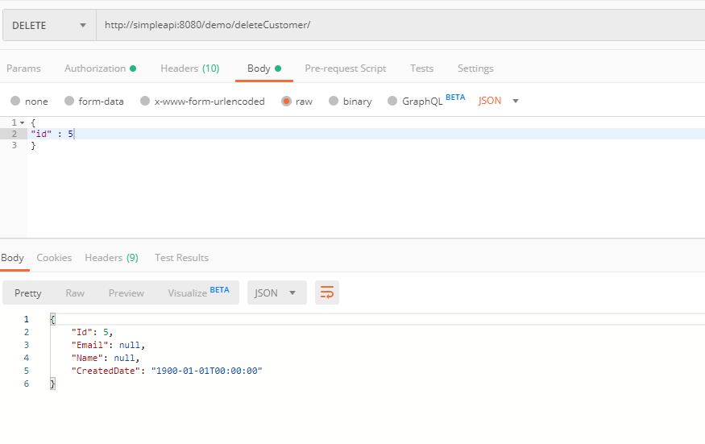

1. **File Upload - (*demo/FileUpload/)**

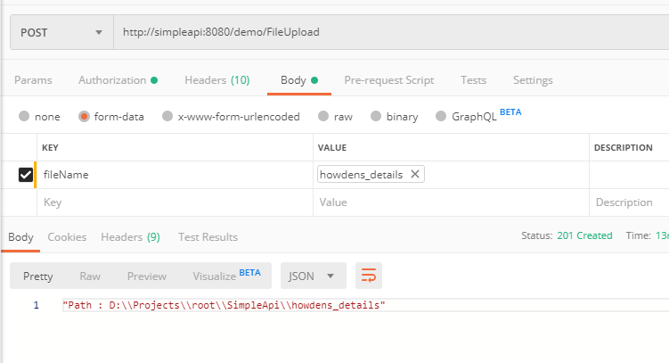

1. **File Download V1- (*demo/FileDownload/)**

Note – pass the correct file name uploaded above with the file extension to download the file.

*Ex – codehouse.png*

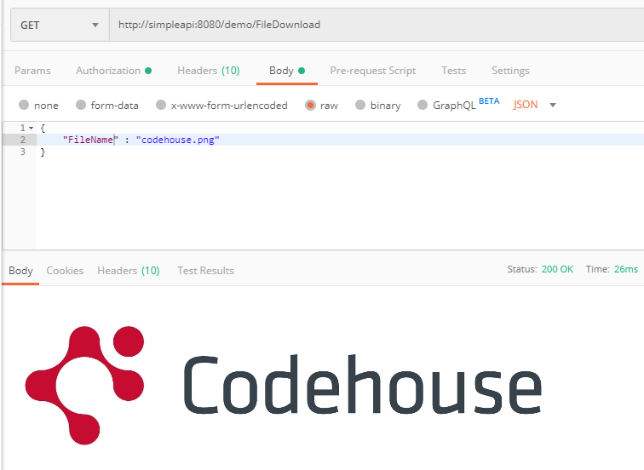

1. File Download V2- (“Demo/FileDownloadPara/")

Same as the above download method. But this one send the file name as a query parameter.

Note – pass the correct file name uploaded above with the file extension to download the file.

*Ex – codehouse.png*

